

CRS REQUEST FOR QUOTATION – RFQ
One Envelope Bidding Process

PROVISION OF Long-lasting Items

Tender Reference: RFGS - SD-CRS-539691-GO-RFQ- SD9581

FUNDED BY

World Bank

Request for Quotation

Title: Procurement of Printers

Name of Project: Enhancing Community Resilience / Thabat Project
Grant No.: E4710 – SD
Procurement Plan Ref: RFGS - SD-CRS-539691-GO-RFQ- SD9581
RFB number: SD-CRS-539691-GO-RFQ- SD9581

CRS is accepting Bids from suppliers for the Long-lasting items for the Health Facility center

- Requirements and price list

Quotations need to be submitted using the Price List template provided in annex A and the Requirements and technical specifications in annex B.

- Currency

All prices shall be quoted in USD only.
CRS reserves the right to reject any bids submitted in a currency other than the mandatory bidding currency stated above. CRS may not accept bids submitted in another currency than stated above if the Offeror confirms during clarification of bids (paragraph 4) in writing that it will accept a contract issued in the mandatory bid currency and that for conversion the operational rate of exchange of the day of RFQ deadline as stated in the RFQ letter shall apply.

Regardless of the currency of bids received, the contract will always be issued and subsequent payments will be made in the mandatory bidding currency above.

- Language of the Quote:

The quote prepared by the supplier/vendor and all correspondence and documents relating to the quote exchanged by the supplier/vendor and CRS shall be in English.

- Clarification of Solicitation Documents:

Suppliers/vendors requiring any clarification on the Request for quotation, or a pre-bid conference may notify CRS in writing. The response will be made in writing to any request for clarification of the RFB that it receives earlier than one week prior to the Deadline for the Submission of Quote. Written copies of CRS’s response (including an explanation of the query but without identifying the source of inquiry) will be published in the same manner as the present tender. Clarification may be sought in writing to:
CRS Email: sudan.rfgs@crs.org ATTENTION TO PROCUREMENT TEAM

- Delivery of Goods/services

Assuming that the tendering process can be satisfactorily concluded during the month of October 2026, the supplier is expected to deliver the goods in the month of November 2026 after issuance of Purchase Order to selected bidder(s).
DDP (Delivered Duty Paid) INCOTERMS 2020 TO CRS office House House No.1/188 Elneil City, Third class, Omdurman,
The assignment is expected to commence on 1st November 2026.

- Payment terms

Payment will be made within NET 30 days after receipt of the hundred (100%) ordered goods at CRS delivery location, inspection & original invoice.

Payment will be done by Wire Transfer issued in the name of the bidding company. The supplier shall be responsible for payment of any taxes, custom duties, dues, transportation cost, levies or other charges that may be arise from the supply of the goods to CRS.

- Your quotation should include:
- Completed price list (using the template provided in annex A)
- Completed requirements and technical specifications form (using the template provided in annex B)
- Quotation submission form (using the template in Annex C)
- Past References (using the template provided in annex E)
- Delivery Lead Time (Annex F)

CRS approved suppliers:

CRS Approved Master Suppliers Master List (MSL) are not required to submit any additional documents except below:

- Valid business license to operate in the country where the vendor is established and or in the country of destination of the products or services.
- Valid Tax Certificate

- Cost of Providing Quotes

Suppliers/Vendors shall bear all costs associated with the preparation and submission of the quote, and CRS will in no case be responsible or liable for those costs, regardless of the conduct or outcome of the solicitation.

- Quotation’s due date and submission manner

All quotations must be received at the physical address or by email address stated below no later than:

Date: 17, October 2026
Time: 4:00 P.M

- Submission of quotes by hand delivery:
One (1) original copy of duly completed bids must be in a sealed envelope addressed to CRS/Sudan clearly marked by “Bidders Name, Address, legal stamps, signatures and Tender No.” and submit their technical and financial documents (sealed envelopes) and should be deposited in the tender box located at CRS office during office hours Sunday to Thursday (Working days only) from, 8:00 A.M to 4:00 P.M.

CRS Sudan
CRS office House House No.1/188
Elneil City, Third class, Omdurman,

The quotation should be signed and stamped in all relevant places. The envelope should be addressed as follows:

Attn: CRS BID COMMITTEE - SUDAN
Subject: Provision of long-lasting Items
Ref: SD-CRS-539691-GO-RFQ- SD9581

OR

- Submission of quotes to a secured email:

You can submit your quotation by email only to: tenders.sudan@crs.org . Your email must not exceed 3MB. Please specify in the message subject line, the above RFB reference number. CRS has right not to accept documents shared through google drive or any other link. Submission of quotation to any other email address will disqualify the bidder from tendering process.

The quote shall remain valid for Ninety (90) days after the closing date prescribed by CRS. Any prices accepted during this period will be considered firm/fixed for the resulting purchase order.

CRS has right to award in total or partial quantity for any one or both items to selected bidders. The supplier agrees to acknowledge the purchase order in the form provided upon award, under the terms and conditions stated herein, and for the agreed amount.

- Amendments of Request for Quotation:

No later than 20 October 2026 prior to the Deadline for Submission of Quotes, CRS may, for any reason, whether at its own initiative or in response to a clarification requested by a prospective supplier/vendor, amend the Request for Quotation. In order to afford prospective suppliers/vendors reasonable time in which to take the amendments into account in preparing their offers, CRS may, at its discretion, extend the Deadline for the Submission of Quotes. Any amendments will be published in the same manner as the present tender.

- Qualification and Evaluation Criteria

Quotations shall be evaluated to determine the lowest price (best value) and most technically acceptable offer. CRS will evaluate the received bids and award the assignment based on Qualification and financial feasibility (Most Advantageous Bid).

Quotations shall be evaluated to determine the lowest priced (best value) most technically acceptable offer that meets CRS’s delivery schedule requirements:

- Compliance with required specifications/technical requirements
- Estimated time of delivery/effectiveness
- Lowest price offered
- Warranty offered
- Discounts offered

- Financial evaluation:
- Offers that are found technically compliant shall be evaluated financially.
- Arithmetical errors will be rectified on the following basis: If there is a discrepancy between the unit price and the total price that is obtained by multiplying the unit price and quantity, the unit price shall prevail and the total price shall be corrected. If the Supplier/Vendor does not accept the correction of errors, its Quote will be rejected. If there is a discrepancy between words and figures the amount in words will prevail.

- Most Advantageous Bid
The CRS shall use the criteria and methodologies listed in Section XI below to determine the Most Advantageous Bid. The Most Advantageous Bid is the Bid of the Bidder that meets the qualification criteria and whose Bid has been determined to be:

- substantially responsive to the bidding document
- Meet minimum technical criteria; and
- the lowest evaluated cost.

- Clarification of Quotes

To assist in the examination, evaluation and comparison of Quotes, CRS may at its discretion ask the Supplier/Vendor for clarification of its Quote. The request for clarification and the response shall be in writing and no change in price or substance of the Quote shall be sought, offered or permitted within 48 hours after receipt of email for clarification.

- Eligibility

Offerors must not be associated or have been associated in the past directly or indirectly with a firm or any of its affiliates which have been engaged by CRS to provide services for the preparation of the design, specifications and other documents to be used for the procurement of the goods under this request for quotation.

Offerors shall not be eligible to submit an offer and to be awarded a contract when, at the time of quotation submission:
- Offerors are already suspended by CRS or by other United Nations, the World Bank or public international entities.
- Offerors name are associated with terrorism and appear in the list that the European Union, the U.S. Government and the United Nations Security Council have published identifying individuals and organizations considered to be associated with terrorism.
- Offeror does not possess a valid business license to operate in Sudan.
- Offerors refuse to comply with Sudan Government Laws: CRS suppliers code of conduct, Code of Conduct for the Protection of Beneficiaries of Assistance from Sexual Exploitation and Abuse in Humanitarian Relief Operations and Standards of Conduct and Disclosure.
Furthermore, as a condition to doing business with CRS, it is necessary that the supplier, their subsidiaries, agents, intermediaries and principals cooperate with the CRS or its agent in the conduct of evaluation, review, audit, inspection, assurance validation, counter-fraud activities, investigations or other action.
Failure to fully cooperate with investigations will be considered sufficient grounds to allow CRS to repudiate and terminate the contract, and to include the supplier on CRS list of suspended suppliers.

As described in the standard Terms and Conditions, Bidders while conducting their activities, are expected to comply with the following policies and regulations: with:

- CRS Suppliers Code of Conduct
- Code of Conduct for the Protection of Beneficiaries of Assistance from Sexual Exploitation and Abuse in Humanitarian Relief Operations
- Standards of Conduct and Disclosure
- CRS General Terms & Conditions for Goods & Services

- Samples

No samples are required with bidding documents for this RFQ.

- Purchaser’s Right to Vary Requirements at Time of Award
CRS reserves the right at the time of making the award of contract to increase or decrease by up to 50 - 70 % the quantity of goods specified in the Request for Quotation without any change in unit price or other terms and conditions.
- Notification of Award:
Prior to the expiration of the period of Quote Validity, CRS will send the successful Supplier/Vendor the Contract. The Contract may only be accepted by the Supplier/Vendor’s signing and returning an acknowledgement copy of it or by timely delivery of the goods in accordance with the terms of this Contract, as herein specified. Acceptance of this Contract shall affect a contract between the parties under which the rights and obligations of the parties shall be governed solely by the terms and conditions of this Contract.
- Signing of the Contract:

Within 3 working days of receipt of the Purchase Order / Contract the successful Supplier/Vendor shall sign, date and return it to CRS.

- Vendor Protest
Our vendor protest procedure is intended to afford an opportunity to appeal to persons or firms did not award a Contract or contract in a competitive procurement process. It is not available to non-responsive or non-timely proposers/bidders or when all proposals/bids are rejected. In the event that you believe you have not been fairly treated, you can find detailed information about vendor protest procedures on www.crs.org .
- INSPECTION OF GOODS
- The Supplier guarantees that the goods shall be of the quality specified in all ways to the specifications of the pro-forma Invoice and other descriptions set forth in technical specifications generally applicable to the goods sold.
- Should the goods fail to meet the specifications in the pro-forma invoice and as well different from the sample the Supplier shall replace the goods at its own cost. If any major defects are found in the goods during inspection CRS Sudan reserves the right to reject the entire consignment and seek damages for breach of contract.

- Bid Securing Declaration
The Bidder shall fill in Annex H Bid Securing Declaration Form in accordance with the instructions indicated
- Delivery Conditions & Delivery Place
- The delivery of goods shall be up on demand issuance of the purchase order, and the Supplier agreed to finalize as per delivery deadline starting from the date of signing of Purchase order / contract. Where there is a delay in the delivery of the goods purchased under this contract, CRS Sudan reserves the right to claim damages equal to 1% of the price of the goods for each day of delay to a maximum of 5 % of the value of the goods.
- The Supplier shall deliver the required goods as per approved specifications by CRS at CRS office House House No.1/188 Elneil City, Third class, Omdurman, The price in Annex A includes costs of transportation.
- The vendor is responsible for transporting the goods at CRS office House House No.1/188 Elneil City, Third class, Omdurman,
- If the goods are not delivered for any reason (excluding force majeure) within agreed period of time, CRS Sudan reserves the right to cancel the Purchase Order immediately upon notification to the Supplier, and the Supplier shall reimburse buyer any payments already made.
- Environmental and Social Standards

- The Supplier shall implement its activities in accordance with the applicable Environmental and Social Standards (ESSs) under the World Bank’s Environmental and Social Framework and comply with the Project’s Environmental and Social Commitment Plan, Environmental and Social Management Plan.
- Labor and Working Conditions
    - Employ workers in accordance with Sudanese national labor laws.
    - Avoid use of child labor or forced labor in any form.
    - Provide written contracts and fair wages.
    - Maintain safe and healthy working conditions.
    - The supplier must ensure adequate measures are in place for the health and safety of its workers and surrounding communities.
- Prevention of Sexual Exploitation, Abuse, and Harassment (SEA/SH) All workers must:
- Sign and comply with a Code of Conduct prohibiting SEA/SH.
- Ensure staff receive SEA/SH awareness training.
- Termination for E&S Non-Compliance: Failure to comply with the obligations in this Bidding document, including E&S standards, may result in corrective actions or disqualification.

Annex A: Price list.

The following document forms part of this RFB and must be completed and returned with your offer.

No | Items Description | Quantity | Unit of Measure | Unit prices in USD | Total Prices in USD
1 | Standard office table high quality  Size 120cm with drawers | 24 | Each
2 | Standard office chairs swivel high quality | 24 | Each
3 | Plastic sheet - mats (Family size) 180cm X 290cm | 60 | Each
4 | Bed sheet blue color high quality | 84 | Each
5 | Metallic Shelves (length 180*120 cm) as per design | 24 | Each
6 | Metallic cupboard (length 1.5 m* width 80 cm) | 48 | Each
7 | Standard metallic bench steel with three seats | 72 | Each
8 | Padlock type top security (medium size) | 120 | Each
9 | Hand tourch( solor charge) | 48 | Each
10 | Curtains(High quality) for office windows | 144 | Each
11 | Hand washing facility ceramic high quality | 120 | Each
12 | Water tank 2000 Ltr size | 10 | Each
13 | Water tank 1000 Ltr size | 10 | Liter
14 | Water pump 1HP | 10 | Each
15 | Medical/safety shoes different size (40, 41, 42,43, 44) | 24 | Each
16 | Safety Boxes | 84 | Each
17 | Plastic Pallets are standard size 1200 mm x 800 mm  for warehouse use. | 60 | Each
18 | Plastic sheet 4X6M | 24 | Each
19 | Vertical roll-up banner (200 × 85 cm), made of durable, water- and dust-resistant vinyl, with a lightweight aluminum stand for easy use and transport. Used in health facilities to display safeguarding awareness messages. | 24 | Each
20 | PAPER, A4, printer quality, white | 72 | Pack/Packet
21 | PEN, ball point, blue | 72 | Pack/Packet
22 | MARKER, permanent - thick, multi-color | 36 | Pack/Packet
23 | MARKER, highlighter, multi-color set | 36 | Pack/Packet
24 | PENCIL, No 2 | 36 | Pack/Packet
25 | RUBBER ERASER, for erasing pencil mark | 36 | Each
26 | PENCIL SHARPENER, manual | 36 | Each
27 | NOTEBOOK, A4, spiral binding | 172 | Each
28 | NOTEPAD, A4 | 156 | Each
29 | PAD (POST-IT), adhesive, 76x127mm, lg | 175 | Each
30 | STAMP PAD, blue | 60 | Each
31 | PAPER CLIP, 33 mm (stan) | 36 | Each
32 | BINDER CLIP, 51mm | 36 | Pack/Packet
33 | BINDER CLIP, 32mm | 36 | Pack/Packet
34 | STAPLE, 24/6 | 36 | Each
35 | STAPLE, 13/14 (heavy duty) | 36 | Each
36 | STAPLER, handheld manual | 36 | Each
37 | STAPLE REMOVER (check STAPLE size) | 36 | Each
38 | HOLE PUNCH, 4 hole, desktop | 36 | Each
39 | WHITEBOARD, size to be provided | 24 | Each
40 | FLIP CHART PAPER, 30 Sheets | 36 | Each
41 | FLIP CHART STAND | 12 | Each
42 | MARKER, Whitebird - thick, multi-color | 12 | Each
43 | ERASER, Whitebird | 24 | Each
44 | TAPE, masking, 19mmx66m | 36 | Each
45 | GLUE, Stick, 75g | 36 | Each
46 | SCISSORS, office, sm (12cm) | 36 | Each
47 | PAPER CUTTER, provide specs | 36 | Each
48 | RULER, 30 cm | 36 | Each
49 | TAPE, brown reinforced., 50mmx66m | 36 | Each
50 | FOLDER, Plastic, Transparent (Multicolored) | 72 | Each
51 | Box File / Kent | 144 | Each
52 | Enveloped large A4paper size | 36 | Each
53 | Plastic Envelope, A4 size (Transparent) | 72 | Each
54 | Torch for HFs Gard’s and midwifs Solar rechargble | 48 | Each
55 | Blue registration book , A4 paper size, 200 sheet | 84 | Each
56 | Electronic calculator (Falamingo) | 60 | Each
57 | Loud speaker for mobile teams | 3 | Each
58 | School Bags with CRS logo | 240 | Each
Total In USD

SUPPLIER AGREES TO SUPPLY ALL GOODS AS SPECIFIED IN THIS BID AND IN ACCORDANCE WITH THE TERMS AND CONDITIONS OF THIS BID AT THE PRICES QUOTED ON THIS FORM

Offeror’s discount for accelerated payment: ______________% of the total firm price for each calendar day less than thirty days

Exact name and address of the company:
Company’s name
Address
Phone number
Name of the contact person
Email of the contact person
Authorized Signature: |  |  |  | Date:
Name of the authorized signatory:
Functional title of signatory:

Annex B: Requirements and Technical Specifications Form

The following document forms part of this RFQ and must be completed and returned with your offer.

Any products meeting the minimum requirements shall be considered.
Offerors are required to complete the table below with YES’, ‘NO’ or specific information requested for the items being supplied. Answers such as ‘see specifications attached’ are unacceptable. Your offer may be considered as non-compliant unless all questions are answered thoroughly. Offerors are NOT allowed to make any change in the ‘Our minimum requirements’ column of the comparative data table below. Such changes might disqualify your offer.

The products offered are genuine and in accordance with the specifications and requirements mentioned in the above Annex A.

Tick the box: Yes or No:

Yes ☐

No ☐

Any deviations/exceptions must be listed below:
_________________________________________________________________________________________________________

________________________________________________________________________________________________________

Annex C: Quotation submission Form

The following document forms part of this RFQ and must be completed and returned with your offer

Quotations must be made in accordance with the instructions contained in this request.
Quotation must be completed in English, signed and returned to CRS prior the indicated closing date/time.

CRS Terms and conditions for goods/services will apply to any resulting purchase order/Contract. A copy of CRS Terms and conditions for goods/services are provided in annex D.

The undersigned having read the Terms and conditions for goods/services of quotation Number SD-CRS-539691-GO-RFQ- SD9581 set out in the attached document, thereby offers to supply the goods/services specified in this RFQ at the price or at the prices quoted in accordance with any specifications stated and subject to the Terms and conditions for goods/services set out or specified in the document

I, the undersigned, declare that:
- Our firm and our personnel have no conflict of interest in any activity that would put it if selected for this assignment in a conflict of interest with CRS
- Our firm confirms that the offeror or sub-contractors have not been associated, or had been involved in any way, directly or indirectly with the preparation of the design, terms of reference and/or other documents used as part of this solicitation
- Our firm, its affiliates or subsidiaries – including any sub-contractors or suppliers for any part of the contract – has not been declared ineligible by CRS in accordance with clause XIII – Eligibility
- We have not offered and will not offer gifts and/or favors of kind in exchange for this RFB and will not engage in any such activity during the performance of any contract awarded

I, _______________________________(name of authorized signatory)_____________, certify that I am _____________(position)______________of ________________________(legal name of the company)_______________; that by signing this RFB bid for and on behalf of _________________________(legal name of the company)____________________ I am certifying that all information contained herein is accurate and truthful and that the signing of this bid is within the scope of my powers.

_______________________ _____________________ _____________________
(Signature) (Name) (Title)

__________________
(Date)

Provide the name and contact information for the primary contact from your company for this quotation:

Name: _______________________________ Title: ___________________________________

Mailing address (street name/number/city/town/province/state):

______________________________________________________________________________________________________

Tel No: ___________________________________

Email address: __________________________

Offer valid until:______________________( Date) Must be at least 30 days

Currency of offer:______________________

Annex C: Quotation submission form continued:

Payment terms: Payment will be made within NET 30 days after receipt of the goods, inspection report, duly signed GRN & original Invoice.

Payment will be done by Wire Transfer issued in the name of the bidding company or bank transfer onto the account of the bidding company.

All quotations must be received at the physical address or by e mail address stated below no later than:

Date: 17, October 2026
Time: 4:00 P.M

CRS Sudan
CRS office House House No.1/188
Elneil City, Third class, Omdurman
or

Email Address for submission of quotation: tenders.sudan@crs.org

Offerors are responsible for the timely submission or delivery of the quotation. Submission of quotation to any other email address or after the closing date & time will not be considered by CRS.

Annex D: Catholic Relief Services’ Standard Terms and Conditions

Catholic Relief Services’ Standard Terms and Conditions can be found at http://crs.org/vendor-terms/vendor-terms.pdf, or obtained from CRS upon request, and are binding as applicable under local law.

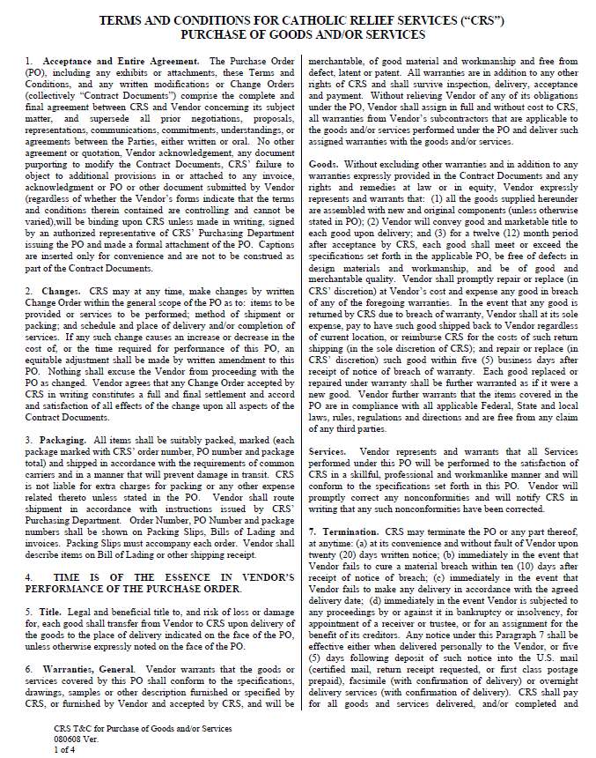
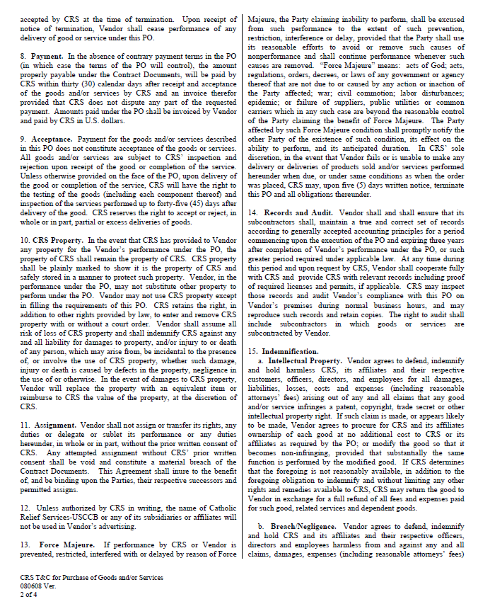

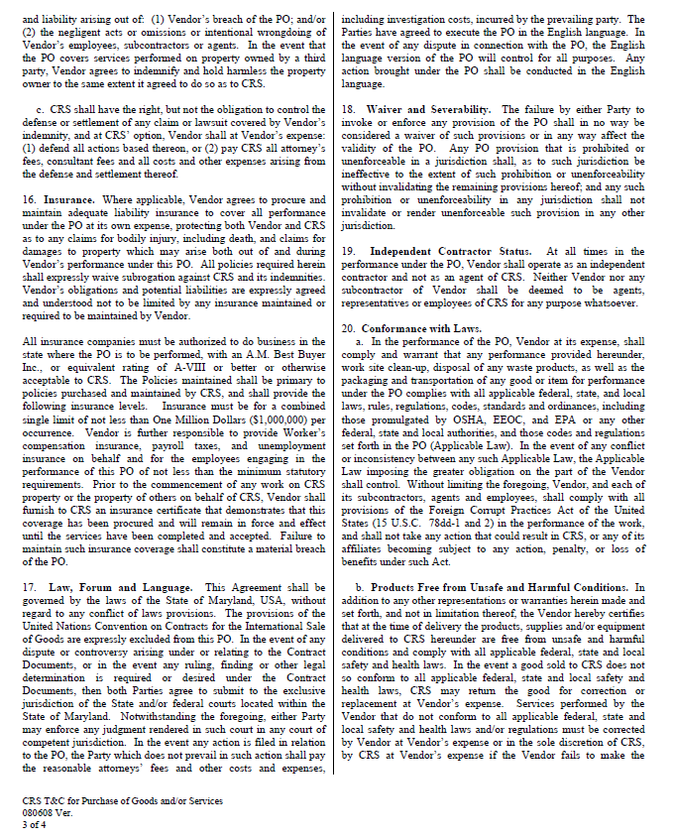

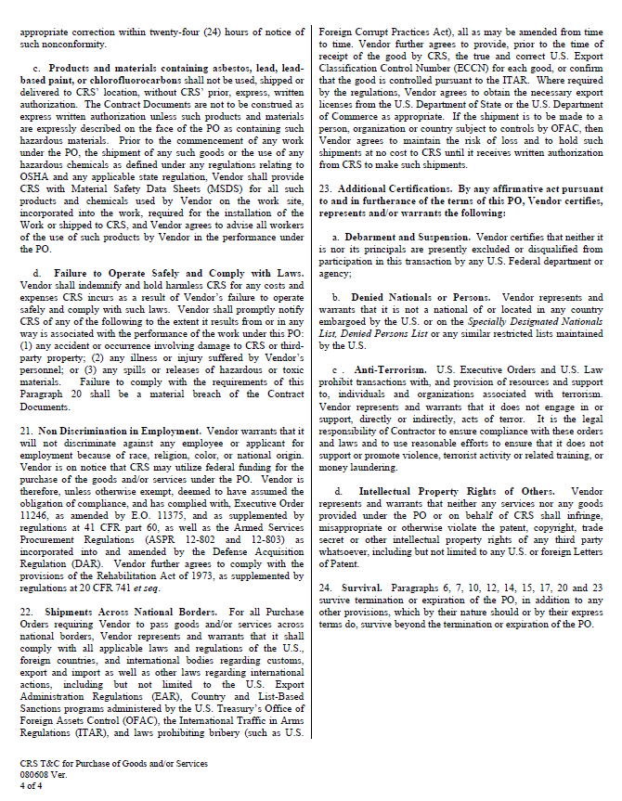

Annex E: Past References form

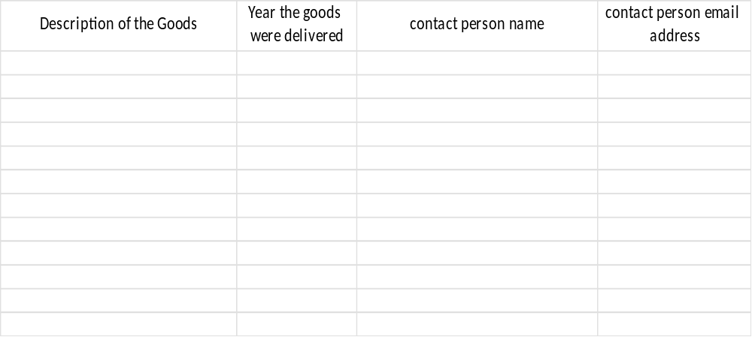

Authorized Signature :________________________________________________________

Date: ___________________________________

Annex F: Offered Delivery Lead Time

(To be filled by bidder)

Serial# | Description | Offered Delivery Lead time (Calendar Days) | Offered Delivery Place
1 | All the above items

Remarks

________________________________________________________________________________________________________________________

________________________________________________________________________________________________________________________

Authorized Signature: ________________________________________________________

Date: ___________________________________

Annex G: SUPPLIER/SERVICE PROVIDER CODE OF CONDUCT

SUPPLIER / SERVICE PROVIDER CODE OF CONDUCT
Catholic Relief Services (CRS) has committed to the principles of responsible sourcing and we expect our suppliers and service providers to fully follow the applicable contractual obligations to include CRS terms & conditions, local and relevant/otherwise applicable laws and to adhere to internationally recognized environmental, social, and corporate governance standards. We also expect our suppliers to implement these standards with their suppliers and subcontractors, as inspired by the United Nations Global Compact initiative, the United Nations Guiding Principles and Human Rights, the International Labour Organization's Declaration on Fundamental Principles and Rights at Work, ETI Base Code, and applicable CRS’ Policies, Procedures and Standards.

- SOCIAL
  - Prohibit all forms of harassment, sexual harassment, exploitation and abuse, including sexual exploitation and abuse, and trafficking in persons.¹ All sexual activity with a child, defined as person under the age of 18 years, is considered sexual abuse regardless of local age of consent.
  - Have mechanisms in place to actively prevent, address, and respond to harassment, sexual harassment, exploitation and abuse, including sexual exploitation and abuse, and trafficking in persons.
  - Support the protection of internationally proclaimed human rights and prohibit forced, bonded, and involuntary labor and child labor.
  - Do not recruit or employ children under the age of 15 years. Do not recruit or employ children under 18 years for work that is mentally or physically dangerous or interferes with schooling.
  - Treat employees with dignity and respect and supply a workplace that is safe and hygienic, complies with national laws, and is free from discrimination on the basis of race, gender, age, religion, sexuality, culture or disability.
  - Provide accessible and confidential reporting mechanisms for employees and other stakeholders to report concerns or suspicions of any forms of harassment, abuse and exploitation described above and potentially unlawful practices by management or employees.
  - Commit to protecting reporters or whistleblowers from retaliation.
  - Uphold the freedom of association and the right to collective bargaining as set out within applicable laws.
  - Ensure wages and working hours meet national legal standards.

- GOVERNANCE
  - Abide by all applicable national and international trade laws and regulations including but not limited to antitrust, trade controls, and sanction regimes.
  - Consider business integrity as the basis of business relationships.
  - Prohibit all types of bribery, corruption, money laundering and terrorism financing
  - Forbid gifts to private or public officials that aim to influence business decisions or otherwise encourage them to act contrary to their obligations.
  - Respect the privacy and confidential information of all your employees and business partners as well as protect data and intellectual property from misuse.
  - Have data protection and managements standards in place that address data collection, safeguarding, sanitation and disposal. The data owner is aware of the data provision terms and conditions and supplies consent as per CRS Responsible Data Values and Principles
  - Implement a proper Compliance Management policy and procedure, which facilitate compliance with applicable laws, regulations, and standards.

1 Refer to pages 6 and 7 of CRS’ Policy on Safeguarding for further details on prohibited exploitative conduct, including procurement of commercial sex, employment practices, and relationships with beneficiaries that are exploitative or abusive.
- ENVIRONMENT
  - Follow all applicable environmental, health and safety regulations.
  - Promote the safe and environmentally sound development, manufacturing, transport, use and disposal of your products.
  - Ensure by using proper management policies and procedures that product quality and safety meet the applicable requirements.
  - Protect your employees’ and neighbors’ life and health, as well as the public at large against
hazards inherent in your processes and products.
  - Use resources efficiently, apply energy-efficient and environmentally friendly technologies and reduce waste, as well as emissions to air, water, and soil.

Because CRS is a recipient of numerous grants or contracts provided by governmental, public, and private donors, all suppliers and service providers are hereby notified that other donor-specific compliance measures may be included in the legal instrument through which goods or services are procured.

CRS reserves the right to conduct due diligence audits or assessments to ensure your compliance and will take reasonable steps to investigate or otherwise take appropriate action to address concerns. CRS reserves the right to terminate any relationship for non-adherence to the above mention requirements.

Should you have any concerns or suspicions of any forms of harassment, abuse and exploitation described above and in CRS’ Safeguarding Policy, illegal or improper conduct, CRS requires you to report through any of the following channels:

  - CRS Management
  - CRS Whistleblower site: http://bit.ly/crshotline
  - Email: alert@crs.org
  - Phone/Skype: 1-866-295-2632
  - Mail: (mark “Confidential") Attention: General Counsel Catholic Relief Services
228 W. Lexington Street Baltimore, MD 21201

Ensuring the principles of sustainable development in our supply chain is important to CRS. We hope that as our partner you show your commitment via compliance with your own code of conduct or company policies that embrace these standards.

In accepting business from CRS in the form of a purchase order, contract, or agreement, you are implicitly accepting your organization’s roles and responsibilities outlined in this document.

Annex H: Form of Bid-Securing Declaration
[The Bidder shall fill in this Form in accordance with the instructions indicated.]

Date: [date (as day, month and year)]
Bid No.: [number of RFB process]
Alternative No.: Not applicable

To: [complete name of Purchaser]
We, the undersigned, declare that:
We understand that, according to your conditions, Bids must be supported by a Bid-Securing Declaration.
We accept that we will automatically be suspended from being eligible for bidding or submitting proposals in any contract with the Purchaser for the period of time specified in Section II – Bid Data Sheet, if we are in breach of our obligation(s) under the Bid conditions, because we:
(a) have withdrawn our Bid prior to the expiry date of the Bid validity specified in the Letter of Bid or any extended date provided by us; or
(b) having been notified of the acceptance of our Bid by the Purchaser prior to the expiry date of the Bid validity in the Letter of Bid or any extended date provided by us, (i) fail or refuse to sign the Contract; or (ii) fail or refuse to furnish the Performance Security, if required, in accordance with the ITB.
We understand this Bid Securing Declaration shall expire if we are not the successful Bidder, upon the earlier of (i) our receipt of your notification to us of the name of the successful Bidder; or (ii) twenty-eight days after the expiry date of the Bid validity.
Name of the Bidder*
Name of the person duly authorized to sign the Bid on behalf of the Bidder** _______
Title of the person signing the Bid ______________________
Signature of the person named above ______________________

Date signed ________________________________ day of ___________________, _____
*: In the case of the Bid submitted by joint venture specify the name of the Joint Venture as Bidder
**: Person signing the Bid shall have the power of attorney given by the Bidder attached to the Bid

[Note: In case of a Joint Venture, the Bid-Securing Declaration must be in the name of all members to the Joint Venture that submits the Bid.]

Annex I: Bank guarantee for advance payments form

Note to Bidders: The bank, as requested by the successful Bidder, shall fill in this form in accordance with the instructions indicated.

Date: (Insert date (as day, month, and year) of Bid Submission)
RFQ No. and title: (xx-xxx and title of bidding process)

(Bank’s letterhead)
Beneficiary: (Insert legal name and address of CRS)
ADVANCE PAYMENT GUARANTEE No.: (Insert Guarantee number)

We, [insert legal name and address of bank], have been informed that [insert complete name and address of supplier] (hereinafter called "the supplier") has entered into Contract No. (Insert number) dated (insert date of agreement) with you, for the supply of (Insert types of goods to be delivered) (hereinafter called "the contract"). Furthermore, we understand that, according to the conditions of the contract, an advance is to be made against an advance payment guarantee.
At the request of the supplier, we hereby irrevocably undertake to pay you any sum or sums not exceeding in total an amount of [insert amount(s)¹ in figures and words] upon receipt by us of your first demand in writing declaring that the supplier is in breach of its obligation under the contract because the supplier used the advance payment for purposes other than toward delivery of the goods.
It is a condition for any claim and payment under this guarantee to be made that the advance payment referred to above must have been received by the supplier on its account [insert number and domicile of the account]
This guarantee shall remain valid and in full effect from the date of the advance payment received by the supplier under the contract until (Insert date)². This guarantee is subject to the Uniform Rules for Demand Guarantees, ICC Publication No.458.

---------------------------------------------------------------------
(Signatures of authorized representative(s) of the bank)

¹ The bank shall insert the amount(s) specified in the contract and denominated, as specified in the contract, either in the currency (ies) of the contractor a freely convertible currency acceptable to CRS.
² Insert the Delivery date stipulated in the Contract Delivery Schedule. CRS should note that in the event of an extension of the time to perform the contract, CRS would need to request an extension of this guarantee from the bank. Such request must be in writing and must be made prior to the expiration date established in the Guarantee. In preparing this Guarantee, CRS might consider adding the following text to the Form, at the end of the penultimate paragraph: “We agree to a one - time extension of this guarantee.”

